**Demonstrativo de Produção**

**Hospital Estadual Geral de Goiânia Dr. Alberto Rassi – HGG**

|  |  |  |  |  |
| --- | --- | --- | --- | --- |
| **HGG - 2020** | | | | |
|
| **LINHAS DE CONTRATAÇÕES** | **CONTRATADA** | **MAIO** | **Cumprimento de Meta** | **Variável** |
|
| Internação (Saídas Hospitalares) | **811** | 450 | 55% | **-45%** |
| Atividade Ambulatorial | **17.028** | 3.515 | 21% | **-79%** |
|  | | |  |  |
| **SAÍDAS HOSPITALARES POR ESPECIALIDADE** | **CONTRATADA** | **MAIO** | **Cumprimento de Meta** | **Variável** |
|
| Saídas Cirúrgicas | **622** | 270 | 43% | **-57%** |
| Saídas Clínicas | **167** | 180 | 108% | **8%** |
| Saídas Cuidados Paliativos | **22** | 0 | 0% | **-100%** |
| **TOTAL** | **811** | 450 | 55% | **-45%** |
|  | | |  |  |
| **ATENDIMENTO AMBULATORIAL POR ESPECIALIDADE** | **CONTRATADA** | **MAIO** | **Cumprimento de Meta** | **Variável** |
|
| Consultas Médicas | **11.749** | 3.148 | 27% | **-73%** |
| Consultas Não Medicas | **5.279** | 367 | 7% | **-93%** |
| **TOTAL** | **12.770** | 3.515 | 28% | **-72%** |
|  | | |  |  |
| **CIRURGIAS** | **CONTRATADA** | **MAIO** | **Cumprimento de Meta** | **Variável** |
|
| **Cirurgias** | **660** | 281 | 43% | **-57%** |
|  |  |  |  |  |
| **HEMODINÂMICA** | **CONTRATADA** | **MAIO** | **Cumprimento de Meta** | **Variável** |
|
| **Hemodinâmica** | **30** | 19 | 63% | **-37%** |
|  |  |  |  |  |
| **SADT EXTERNO** | **CONTRATADA (vagas ofertadas)** | **MAIO** | **Cumprimento de Meta** | **Variável** |
|
| **SADT** | **980** | 337 | 34% | **-66%** |

|  |  |  |  |  |  |  |  |  |  |  |  |  |  |  |  |  |  |  |  |  |  |  |  |
| --- | --- | --- | --- | --- | --- | --- | --- | --- | --- | --- | --- | --- | --- | --- | --- | --- | --- | --- | --- | --- | --- | --- | --- |
| **Produção Contratada e Realizada** | | | | | | | | | | | | | | | | | | | | | | | |
| **Hospital Estadual Geral Dr Alberto Rassi- Idtech Contrato: 24/2012 - 13º Termo Aditivo** | | | | | | | | | | | | | | | | | | | | | | | |
| **Serviços** | **jan/20** | | | **fev/20** | | | **mar/20** | | | **abr/20** | | | **mai/20** | | | | **Total do Período** | | | | | | |
| **Contrat.** | **Realiz.** | **Contrat.** | | **Realiz.** | **Contrat.** | | **Realiz.** | **Contrat.** | | **Realiz.** | **Contrat.** | | **Realiz.** | | **Contrat.** | | **Realiz.** | | **% Realiz.** | | **%** | |
| Internação (Saídas Hospitalares) | **996** | 765 | **996** | | 686 | **811** | | 702 | **811** | | 384 | **811** | | 450 | | **4.425** | | **2.987** | | **67,50%** | | **-32,50%** | |
| Atividade Ambulatorial | **17.028** | 16.603 | **17.028** | | 14.347 | **17.028** | | 13.696 | **17.028** | | 2.689 | **17.028** | | 3.515 | | **85.140** | | **50.850** | | **59,73%** | | **-40,27%** | |
| SADT Externo | **980** | 1.087 | **980** | | 1.084 | **980** | | 1.273 | **980** | | 0 | **980** | | 337 | | **4.900** | | **3.781** | | **77,16%** | | **-22,84%** | |
| **Saídas Hospitalares por Especialidade** | | | | | | | | | | | | | | | | | | | | | | | |
| **Serviços** | **jan/20** | | | **fev/20** | | | **mar/20** | | | **abr/20** | | | **mai/20** | | | | **Total do Período** | | | | | | |
| **Contrat.** | **Realiz.** | **Contrat.** | | **Realiz.** | **Contrat.** | | **Realiz.** | **Contrat.** | | **Realiz.** | **Contrat.** | | **Realiz.** | | **Contrat.** | | **Realiz.** | | **% Realiz.** | | **%** | |
| Clínica Médica | **276** | 192 | **276** | | 159 | **167** | | 190 | **167** | | 180 | **167** | | 145 | | **1.053** | | **866** | | **82,24%** | | **-17,76%** | |
| Clinica Cirúrgica | **700** | 546 | **700** | | 502 | **622** | | 489 | **622** | | 204 | **622** | | 270 | | **3.266** | | **2.011** | | **61,57%** | | **-38,43%** | |
| Cuidados Paliativos | **20** | 27 | **20** | | 25 | **22** | | 23 | **22** | | 0 | **22** | | 35 | | **106** | | **110** | | **103,77%** | | **3,77%** | |
| **Total** | **996** | **765** | **996** | | **686** | **811** | | **702** | **811** | | **384** | **811** | | **450** | | **4.425** | | **2.987** | | **67,50%** | | **-32,50%** | |
| **Atendimento Ambulatorial por Especialidade** | | | | | | | | | | | | | | | | | | | | | | | |
| **Atividade Ambulatorial** | **jan/20** | | | **fev/20** | | | **mar/20** | | | **abr/20** | | | **mai/20** | | | | **Total do Período** | | | | | | |
| **Contrat.** | **Realiz.** | **Contrat.** | | **Realiz.** | **Contrat.** | | **Realiz.** | **Contrat.** | | **Realiz.** | **Contrat.** | | **Realiz.** | | **Contrat.** | | **Realiz.** | | **% Realiz.** | | **%** | |
| Consultas Médicas | **11.749** | 11.429 | **11.749** | | 10.786 | **11.749** | | 8.801 | **11.749** | | 2.343 | **11.749** | | 3.148 | | **58.745** | | **36.507** | | **62,14%** | | **-37,86%** | |
| Consultas Não Médicas | **5.279** | 5.174 | **5.279** | | 3.561 | **5.279** | | 4.895 | **5.279** | | 346 | **5.279** | | 367 | | **26.395** | | **14.343** | | **54,34%** | | **-45,66%** | |
| **Total** | **17.028** | **16.603** | **17.028** | | **14.347** | **17.028** | | **13.696** | **17.028** | | **2.689** | **17.028** | | **3.515** | | **85.140** | | **50.850** | | **59,73%** | | **-40,27%** | |
| **Cirurgias** | | | | | | | | | | | | | | | | | | | | | | | |
| **Serviços** | **jan/20** | | | **fev/20** | | | **mar/20** | | | **abr/20** | | | **mai/20** | | | | **Total do Período** | | | | | | |
| **Contrat.** | **Realiz.** | **Contrat.** | | **Realiz.** | **Contrat.** | | **Realiz.** | **Contrat.** | | **Realiz.** | **Contrat.** | | **Realiz.** | | **Contrat.** | | **Realiz.** | | **% Realiz.** | | **%** | |
| Cirurgias | **700** | 595 | **700** | | 518 | **660** | | 550 | **660** | | 219 | **660** | | 281 | | **3.380** | | **2.163** | | **63,99%** | | **-36,01%** | |
| **Procedimentos de Hemodinâmica** | | | | | | | | | | | | |  | |  | |  | |  | |  | |  |
| **Serviços** | **abr/20** | | | **mai/20** | | | **Total do Período** | | | | | |  | |  | |  | |  | |  | |  |
| **Contrat.** | **Realiz.** | **Contrat.** | | **Realiz.** | **Contrat.** | | **Realiz.** | **% Realiz.** | | **%** |  | |  | |  | |  | |  | |  | |
| Hemodinâmica | **30** | 23 | **30** | | 19 | **60** | | **42** | **70,00%** | | **-30,00%** |  | |  | |  | |  | |  | |  | |

Fonte: Escritório da Qualidade

|  |  |  |  |  |  |  |  |  |  |
| --- | --- | --- | --- | --- | --- | --- | --- | --- | --- |
| **Produção Mensal de Consultas Ambulatoriais** | | | | | | | | | |
|  | **2012** | **2013** | **2014** | **2015** | **2016** | **2017** | **2018** | **2019** | **2020** |
| **Jan** |  | 8.829 | 8.177 | 7.425 | 8.000 | 9.965 | 11.032 | 11.536 | 16.603 |
| **Fev** |  | 8.877 | 9.579 | 7.689 | 8.480 | 10.475 | 10.117 | 13.627 | 14.347 |
| **Mar** | 5.266 | 10.313 | 8.346 | 8.900 | 11.529 | 10.936 | 13.161 | 19.533 | 13.696 |
| **Abr** | 9.332 | 11.130 | 7.300 | 7.913 | 9.693 | 11.031 | 12.028 | 19.044 | 2.689 |
| **Mai** | 10.695 | 9.476 | 8.497 | 8.996 | 9.389 | 10.604 | 11.505 | 19.472 |  |
| **Jun** | 9.702 | 8.913 | 7.805 | 8.985 | 11.313 | 9.867 | 11.658 | 15.565 |  |
| **Jul** | 7.901 | 7.568 | 8.369 | 9.169 | 10.248 | 9.046 | 10.537 | 18.568 |  |
| **Ago** | 10.577 | 9.352 | 9.560 | 9.768 | 13.979 | 13.490 | 12.399 | 18.410 |  |
| **Set** | 8.978 | 9.785 | 9.369 | 9.437 | 13.204 | 11.691 | 11.686 | 20.067 |  |
| **Out** | 10.092 | 10.076 | 8.936 | 9.270 | 9.854 | 11.555 | 11.701 | 19.805 |  |
| **Nov** | 9.680 | 8.280 | 8.590 | 9.737 | 14.090 | 12.651 | 14.002 | 19.982 |  |
| **Dez** | 7.894 | 7.619 | 7.188 | 8.359 | 10.446 | 11.019 | 10.769 | 16.982 |  |
| **TOTAL** | **90.117** | **110.218** | **101.716** | **105.648** | **130.225** | **132.330** | **140.595** | **212.591** | **47.335** |
| **Média** | **9.486** | **9.185** | **8.476** | **8.804** | **10.852** | **11.028** | **11.716** | **17.716** | **11.834** |

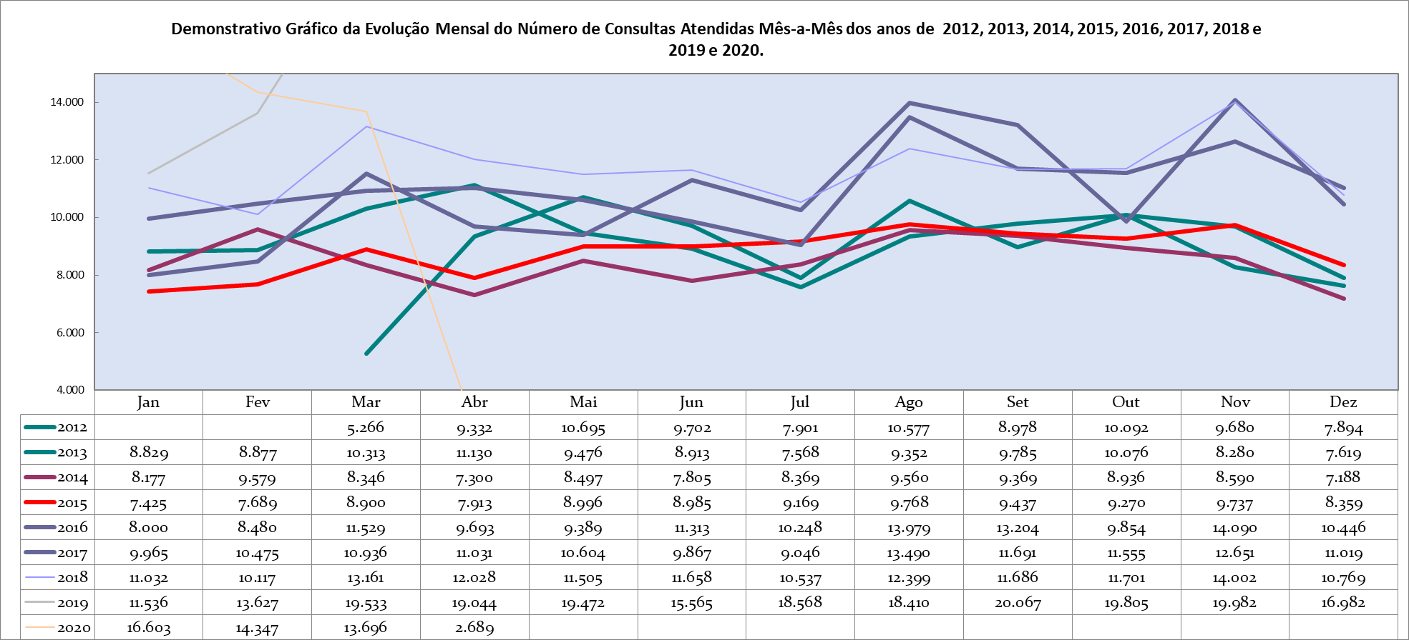

|  |  |  |  |  |  |  |  |  |  |
| --- | --- | --- | --- | --- | --- | --- | --- | --- | --- |
| **Produção Mensal de Atos Multidisciplinares** | | | | | | | | | |
|  | **2012** | **2013** | **2014** | **2015** | **2016** | **2017** | **2018** | **2019** | **2020** |
| **Jan** |  | 8.558 | 9.784 | 9.693 | 12.409 | 17.926 | 16.984 | 12.147 | 12.024 |
| **Fev** |  | 7.893 | 8.254 | 9.264 | 11.138 | 15.308 | 16.968 | 12.009 | 10.637 |
| **Mar** | 4.501 | 9.486 | 8.540 | 8.332 | 13.579 | 17.473 | 21.336 | 11.420 | 11.249 |
| **Abr** | 7.930 | 8.718 | 9.162 | 8.727 | 14.194 | 12.703 | 18.092 | 13.611 | 7.468 |
| **Mai** | 9.529 | 6.787 | 9.128 | 9.963 | 13.524 | 16.628 | 12.060 | 13.224 |  |
| **Jun** | 11.670 | 5.984 | 8.638 | 10.397 | 16.717 | 15.576 | 18.603 | 11.178 |  |
| **Jul** | 7.498 | 7.384 | 9.091 | 10.984 | 15.095 | 15.807 | 19.628 | 13.660 |  |
| **Ago** | 10.008 | 7.765 | 9.879 | 11.507 | 16.514 | 18.245 | 20.613 | 12.054 |  |
| **Set** | 7.823 | 7.046 | 12.383 | 11.243 | 16.386 | 16.873 | 17.459 | 11.949 |  |
| **Out** | 8.656 | 7.324 | 11.671 | 11.418 | 15.437 | 16.378 | 14.719 | 11.645 |  |
| **Nov** | 9.911 | 8.369 | 10.286 | 12.738 | 16.091 | 16.751 | 11.966 | 11.229 |  |
| **Dez** | 7.953 | 10.090 | 11.029 | 11.806 | 15.764 | 17.090 | 10.648 | 9.414 |  |
| **TOTAL** | **85.479** | **95.404** | **117.845** | **126.072** | **176.848** | **196.758** | **199.076** | **143.540** | **41.378** |
| **Média** | **8.548** | **7.950** | **9.820** | **10.506** | **14.737** | **16.397** | **16.590** | **11.962** | **10.345** |

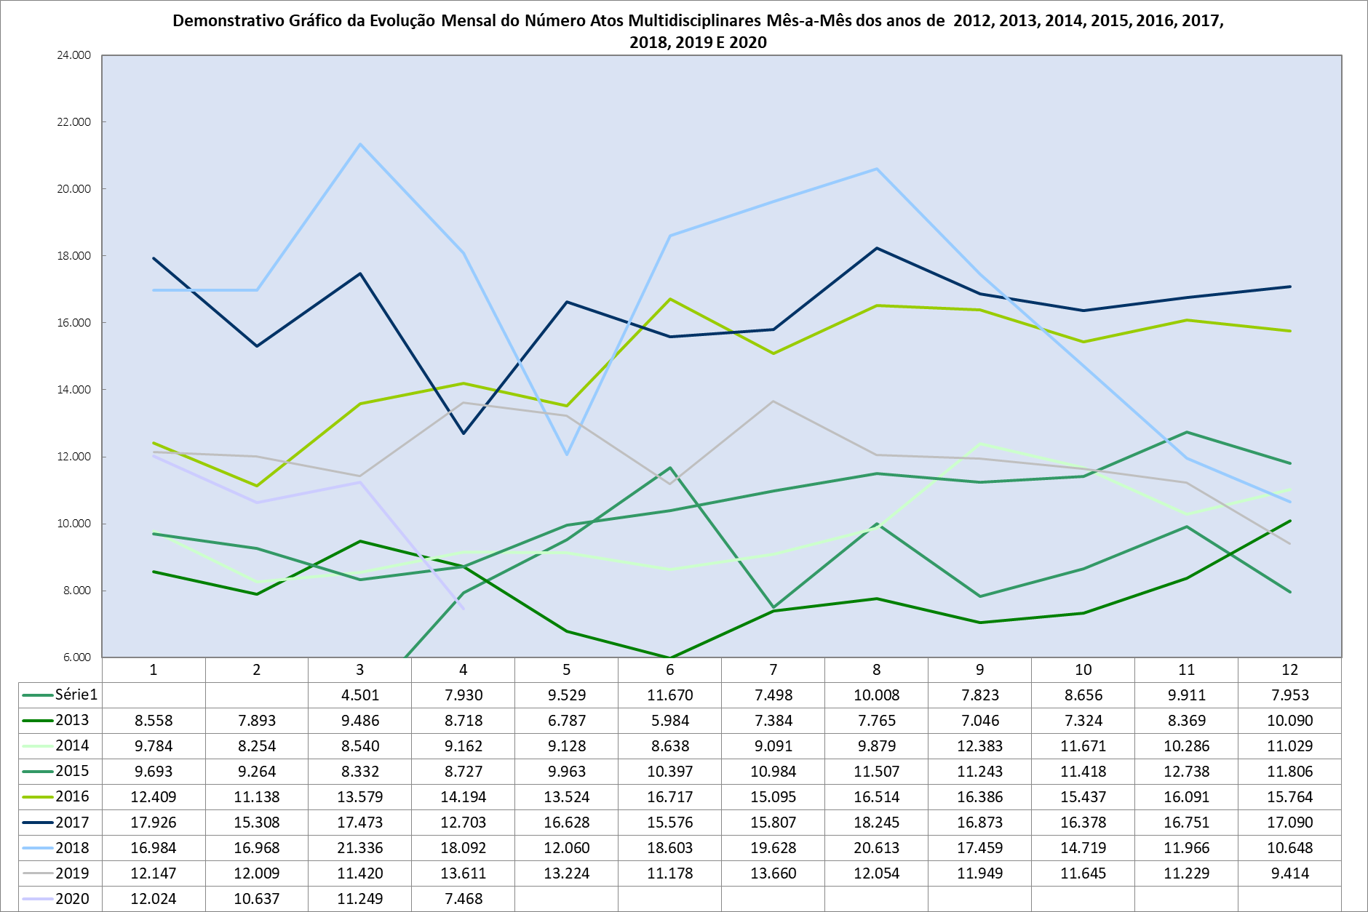

|  |  |  |  |  |  |  |  |  |  |
| --- | --- | --- | --- | --- | --- | --- | --- | --- | --- |
| **Produção Mensal de SADT** | | | | | | | | | |
|  | **2012** | **2013** | **2014** | **2015** | **2016** | **2017** | **2018** | **2019** | **2020** |
| **Jan** |  | 19.935 | 28.161 | 22.443 | 20.808 | 23.823 | 31.507 | 24.420 | 29.904 |
| **Fev** |  | 17.846 | 22.621 | 18.779 | 17.766 | 25.791 | 30.142 | 21.384 | 29.210 |
| **Mar** | 8.282 | 20.759 | 24.065 | 24.011 | 22.797 | 22.326 | 31.360 | 24.644 | 31.965 |
| **Abr** | 16.374 | 20.897 | 23.611 | 23.416 | 24.477 | 29.101 | 32.718 | 28.345 | 27.687 |
| **Mai** | 16.931 | 22.155 | 22.529 | 25.588 | 23.743 | 25.225 | 32.934 | 29.355 |  |
| **Jun** | 17.597 | 21.825 | 22.633 | 25.140 | 25.141 | 32.830 | 31.123 | 28.786 |  |
| **Jul** | 17.371 | 21.094 | 22.728 | 25.862 | 26.136 | 24.233 | 32.431 | 33.344 |  |
| **Ago** | 21.310 | 21.464 | 23.431 | 27.703 | 28.968 | 37.094 | 35.789 | 32.306 |  |
| **Set** | 20.114 | 18.985 | 21.426 | 23.321 | 27.506 | 28.027 | 32.441 | 33.266 |  |
| **Out** | 20.153 | 20.671 | 21.128 | 23.934 | 33.268 | 29.806 | 26.919 | 29.040 |  |
| **Nov** | 17.739 | 20.819 | 24.033 | 22.545 | 27.287 | 28.858 | 19.552 | 29.264 |  |
| **Dez** | 19.513 | 24.664 | 23.629 | 21.651 | 25.821 | 29.905 | 23.069 | 30.388 |  |
| **TOTAL** | **175.384** | **251.114** | **279.995** | **284.393** | **303.718** | **337.019** | **359.985** | **344.542** | **118.766** |
| **Média** | **18.461** | **20.926** | **23.333** | **23.699** | **25.310** | **28.085** | **29.999** | **28.712** | **29.692** |

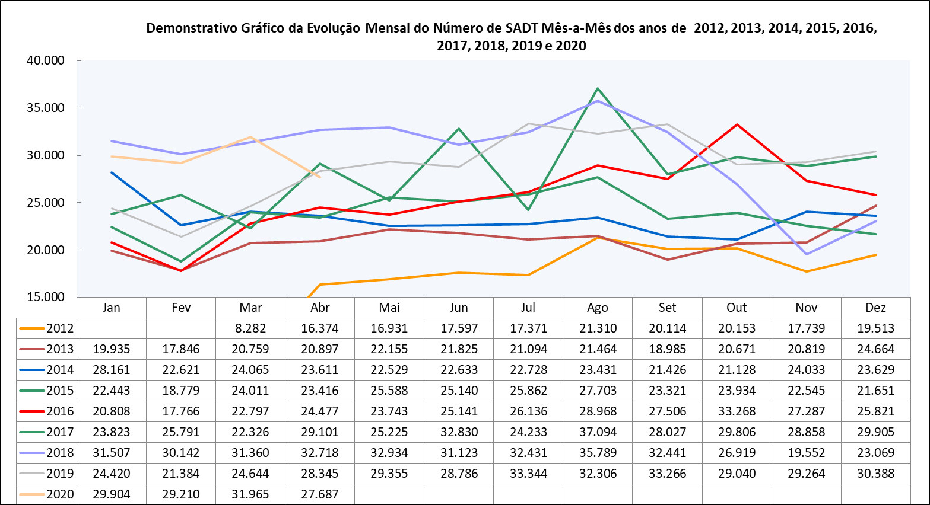

|  |  |  |  |  |  |  |  |  |  |
| --- | --- | --- | --- | --- | --- | --- | --- | --- | --- |
| **Produção Mensal de Cirurgias** | | | | | | | | | |
|  | **2012** | **2013** | **2014** | **2015** | **2016** | **2017** | **2018** | **2019** | **2020** |
| **Jan** |  | 348 | 302 | 276 | 415 | 454 | 520 | 573 | 595 |
| **Fev** |  | 308 | 305 | 280 | 356 | 438 | 478 | 597 | 518 |
| **Mar** | 184 | 412 | 323 | 436 | 488 | 521 | 546 | 598 | 550 |
| **Abr** | 328 | 466 | 328 | 413 | 422 | 468 | 564 | 707 | 242 |
| **Mai** | 357 | 355 | 322 | 498 | 428 | 590 | 634 | 718 |  |
| **Jun** | 353 | 367 | 298 | 490 | 470 | 526 | 576 | 582 |  |
| **Jul** | 383 | 410 | 311 | 537 | 426 | 507 | 651 | 736 |  |
| **Ago** | 450 | 420 | 329 | 539 | 562 | 555 | 663 | 811 |  |
| **Set** | 364 | 331 | 353 | 502 | 488 | 501 | 588 | 700 |  |
| **Out** | 420 | 338 | 390 | 489 | 416 | 505 | 563 | 705 |  |
| **Nov** | 389 | 311 | 379 | 482 | 481 | 526 | 505 | 653 |  |
| **Dez** | 303 | 250 | 340 | 325 | 439 | 476 | 437 | 511 |  |
| **TOTAL** | **3.531** | **4.316** | **3.980** | **5.267** | **5.391** | **6.067** | **6.725** | **7.891** | **1.905** |
| **Média** | **372** | **360** | **332** | **439** | **449** | **506** | **560** | **658** | **476** |

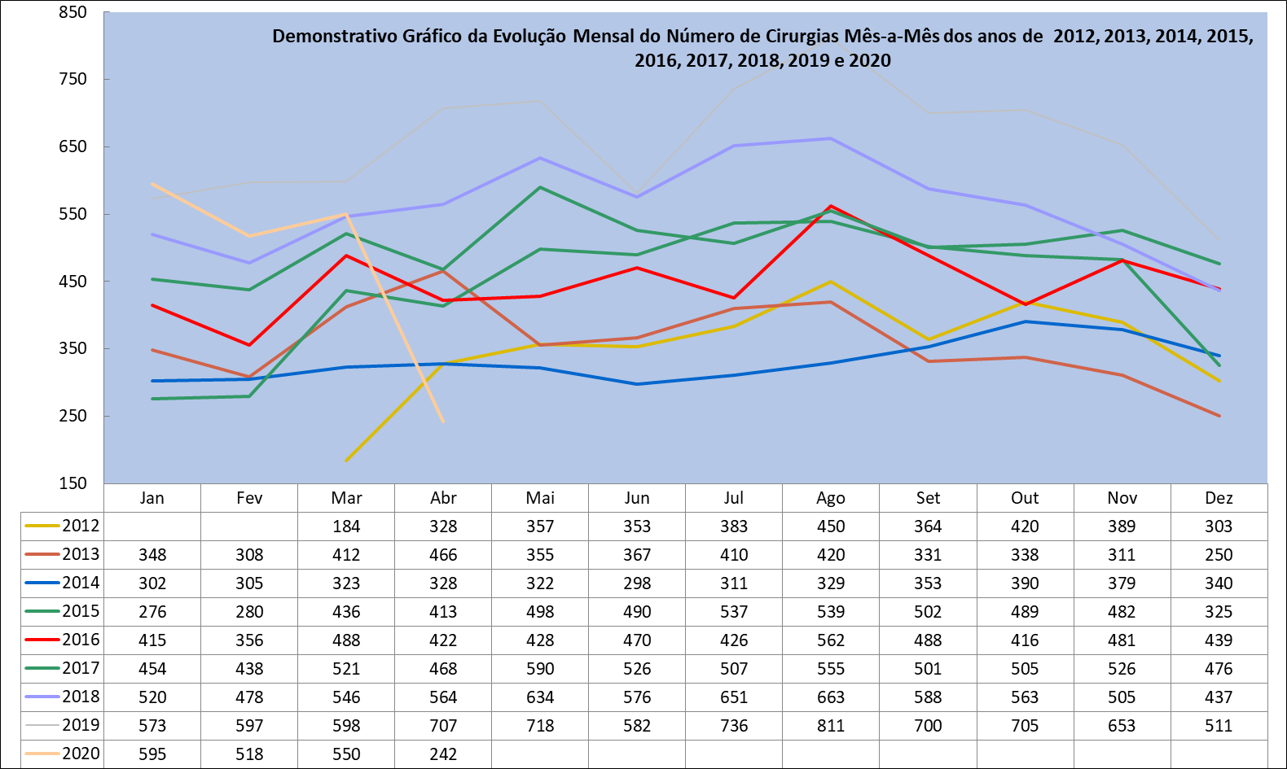

|  |  |  |  |  |  |  |  |  |  |
| --- | --- | --- | --- | --- | --- | --- | --- | --- | --- |
| **Produção Mensal de Internações** | | | | | | | | | |
|  | **2012** | **2013** | **2014** | **2015** | **2016** | **2017** | **2018** | **2019** | **2020** |
| **Jan** |  | 472 | 571 | 476 | 552 | 631 | 738 | 862 | 811 |
| **Fev** |  | 460 | 630 | 490 | 439 | 608 | 606 | 730 | 668 |
| **Mar** | 436 | 594 | 577 | 529 | 522 | 676 | 725 | 763 | 679 |
| **Abr** | 431 | 658 | 593 | 438 | 669 | 637 | 793 | 883 | 394 |
| **Mai** | 459 | 673 | 584 | 722 | 628 | 763 | 796 | 867 |  |
| **Jun** | 482 | 680 | 529 | 630 | 604 | 639 | 791 | 785 |  |
| **Jul** | 475 | 599 | 549 | 593 | 646 | 726 | 826 | 913 |  |
| **Ago** | 587 | 690 | 563 | 584 | 698 | 694 | 840 | 980 |  |
| **Set** | 517 | 572 | 582 | 580 | 646 | 692 | 758 | 864 |  |
| **Out** | 572 | 535 | 607 | 695 | 636 | 730 | 720 | 844 |  |
| **Nov** | 546 | 593 | 555 | 689 | 655 | 701 | 590 | 820 |  |
| **Dez** | 542 | 675 | 548 | 499 | 597 | 673 | 651 | 710 |  |
| **TOTAL** | **5.047** | **7.201** | **6.888** | **6.925** | **7.292** | **8.170** | **8.834** | **10.021** | **2.552** |
| **Média** | **505** | **600** | **574** | **577** | **608** | **681** | **736** | **835** | **638** |

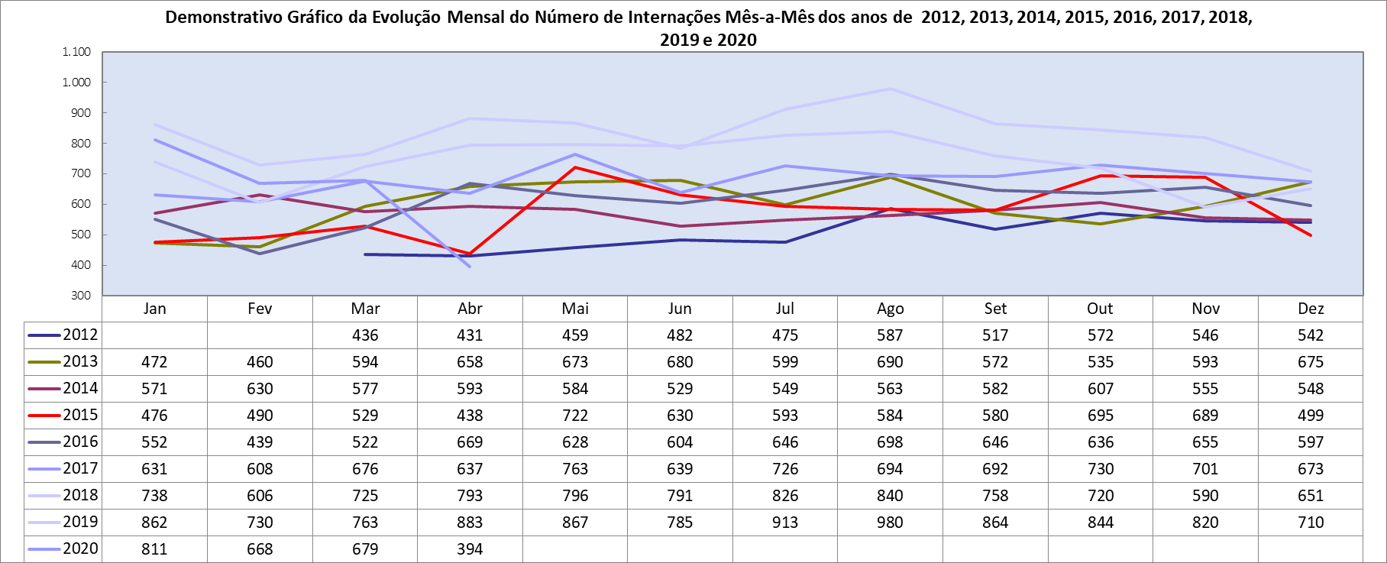

|  |  |  |  |  |  |
| --- | --- | --- | --- | --- | --- |
| **Produção Mensal de Saídas Hospitalares** | | | | | |
|  | **2016** | **2017** | **2018** | **2019** | **2020** |
| **Jan** |  | 553 | 670 | 819 | 765 |
| **Fev** |  | 632 | 593 | 689 | 686 |
| **Mar** | 515 | 652 | 766 | 782 | 702 |
| **Abr** | 566 | 651 | 788 | 863 | 384 |
| **Mai** | 534 | 697 | 771 | 867 |  |
| **Jun** | 581 | 671 | 763 | 782 |  |
| **Jul** | 633 | 698 | 797 | 892 |  |
| **Ago** | 683 | 676 | 823 | 981 |  |
| **Set** | 640 | 689 | 751 | 836 |  |
| **Out** | 622 | 672 | 704 | 838 |  |
| **Nov** | 620 | 691 | 586 | 852 |  |
| **Dez** | 654 | 728 | 698 | 732 |  |
| **TOTAL** | **6.048** | **8.010** | **8.710** | **9.933** | **2.537** |
| **Média** | **605** | **668** | **726** | **828** | **634** |

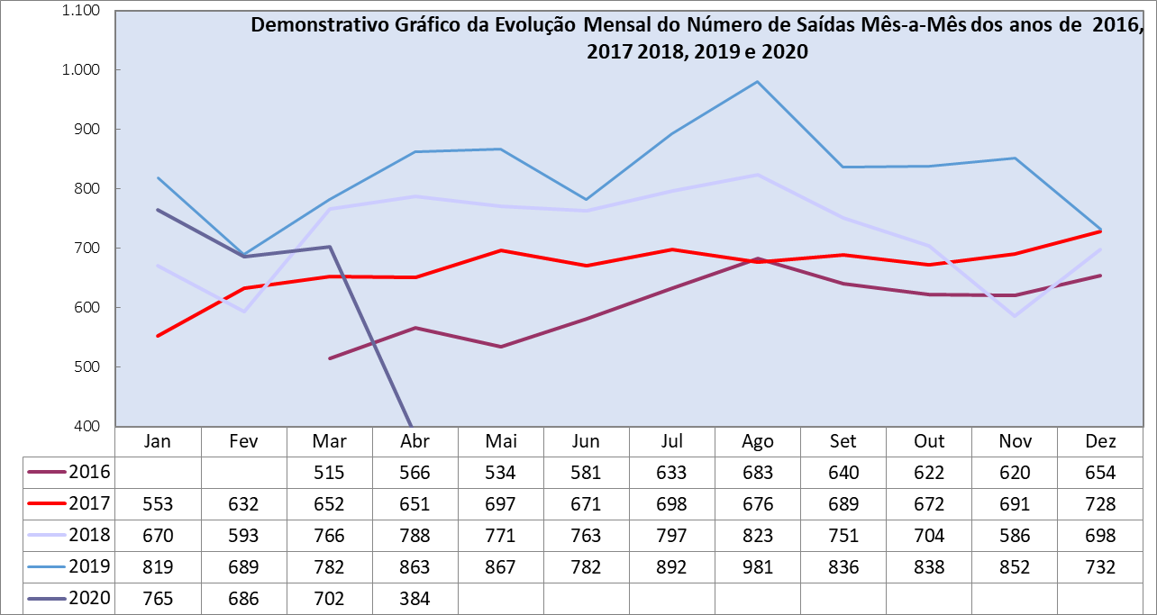

|  |  |  |  |
| --- | --- | --- | --- |
| **Produção Ambulatorial - CEAD** | | | |
|  | **2018** | **2019** | **2020** |
| **Jan** | - | 1.752 | 1.285 |
| **Fev** | - | 1.968 | 1.551 |
| **Mar** | - | 1.554 | 1.426 |
| **Abr** | - | 2.188 | 386 |
| **Mai** | - | 2.054 |  |
| **Jun** | - | 2.115 |  |
| **Jul** | 491 | 1.873 |  |
| **Ago** | 908 | 1.918 |  |
| **Set** | 1.161 | 1.706 |  |
| **Out** | 1.854 | 1.637 |  |
| **Nov** | 1.687 | 1.748 |  |
| **Dez** | 1.738 | 1.495 |  |
| **TOTAL** | **7.839** | **22.008** | **4.648** |
| **Média** | **1.307** | **1.834** | **1.162** |

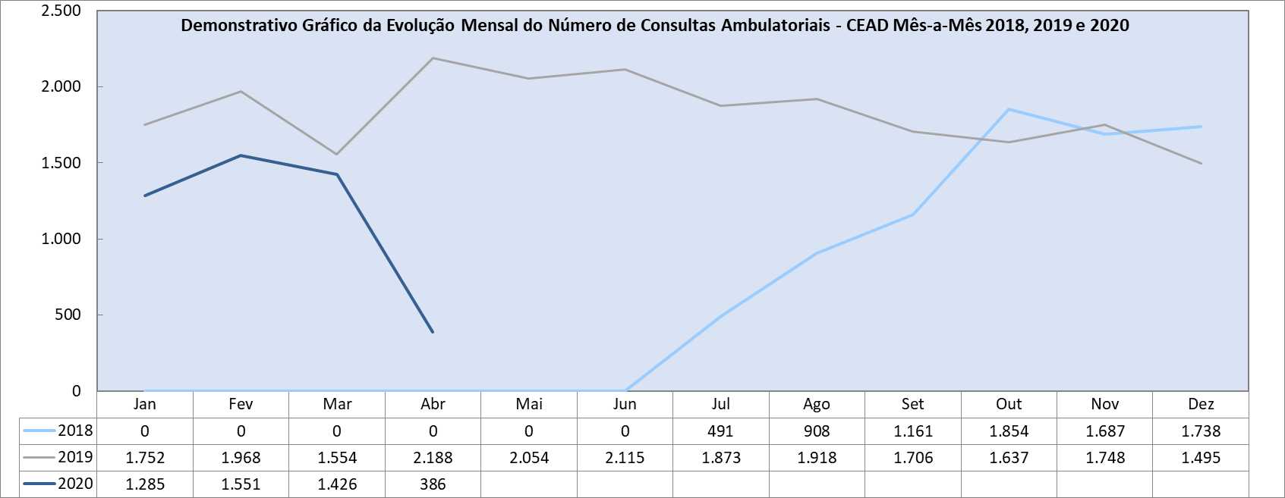

|  |  |  |  |
| --- | --- | --- | --- |
| **Produção Programas Multidisciplinares - CEAD** | | | |
|  | **2018** | **2019** | **2020** |
| **Jan** | - | 593 | 664 |
| **Fev** | - | 557 | 484 |
| **Mar** | - | 580 | 368 |
| **Abr** | - | 531 | 16 |
| **Mai** | - | 531 |  |
| **Jun** | - | 511 |  |
| **Jul** | 69 | 345 |  |
| **Ago** | 56 | 649 |  |
| **Set** | 236 | 664 |  |
| **Out** | 408 | 544 |  |
| **Nov** | 534 | 612 |  |
| **Dez** | 586 | 188 |  |
| **TOTAL** | **1.889** | **6.305** | **1.532** |
| **Média** | **315** | **525** | **383** |

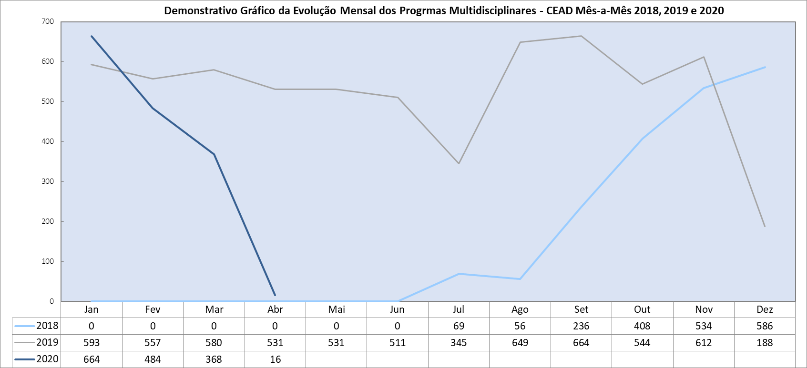

|  |  |  |  |  |
| --- | --- | --- | --- | --- |
| **Produção Mensal de Transplantes Renais** | | | | |
|  | **2017** | **2018** | **2019** | **2020** |
| **Jan** | 0 | 8 | 7 | 15 |
| **Fev** | 0 | 13 | 11 | 7 |
| **Mar** | 13 | 8 | 13 | 25 |
| **Abr** | 8 | 9 | 13 | 4 |
| **Mai** | 4 | 12 | 13 |  |
| **Jun** | 9 | 18 | 9 |  |
| **Jul** | 10 | 15 | 0 |  |
| **Ago** | 11 | 10 | 23 |  |
| **Set** | 6 | 10 | 17 |  |
| **Out** | 3 | 10 | 25 |  |
| **Nov** | 14 | 13 | 29 |  |
| **Dez** | 5 | 5 | 6 |  |
| **TOTAL** | **83** | **131** | **166** | **51** |
| **Média** | **7** | **11** | **14** | **13** |

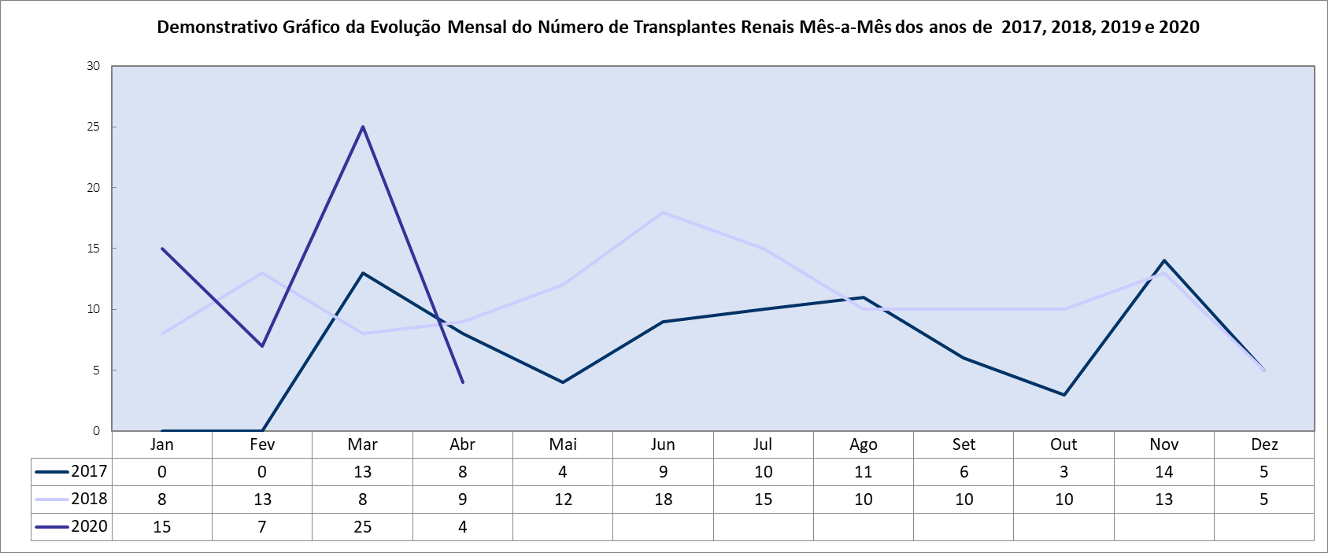

|  |  |  |  |
| --- | --- | --- | --- |
| **Produção Mensal de Transplantes Hepáticos** | | | |
|  | **2018** | **2019** | **2020** |
| **Jan** | 0 | 0 | 1 |
| **Fev** | 0 | 1 | 0 |
| **Mar** | 0 | 1 | 0 |
| **Abr** | 0 | 0 | 0 |
| **Mai** | 0 | 0 |  |
| **Jun** | 0 | 2 |  |
| **Jul** | 1 | 0 |  |
| **Ago** | 0 | 2 |  |
| **Set** | 0 | 0 |  |
| **Out** | 0 | 0 |  |
| **Nov** | 1 | 0 |  |
| **Dez** | 3 | 0 |  |
| **TOTAL** | **5** | **6** | **1** |
| **Média** | **0** | **1** | **0** |

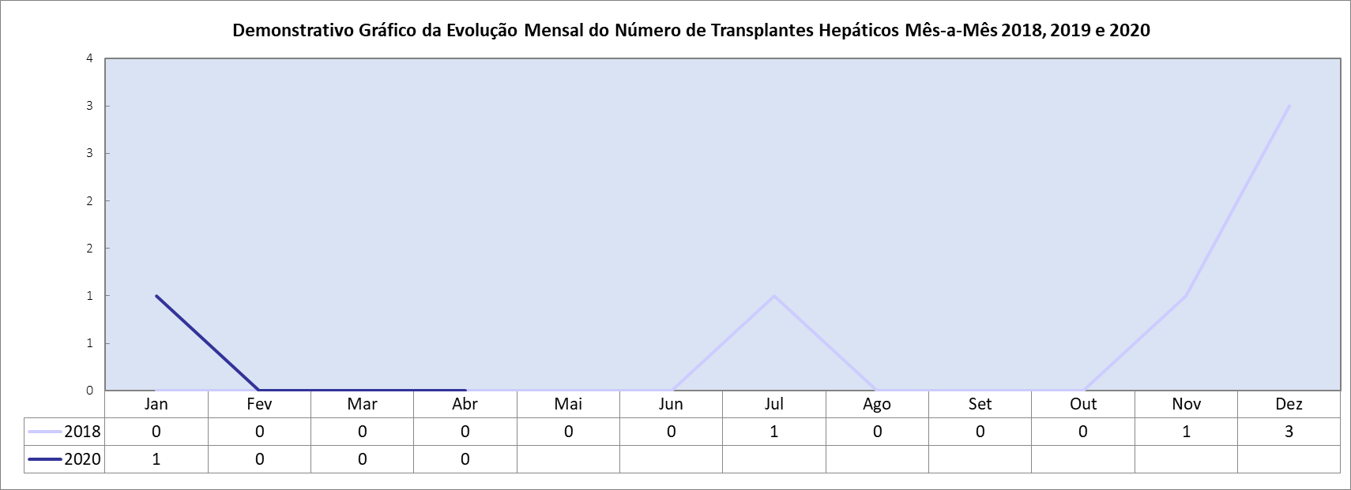

|  |  |  |  |  |  |  |  |  |
| --- | --- | --- | --- | --- | --- | --- | --- | --- |
| **Novos serviços implantados no HGG – Status de funcionamento** | | | | | | | | |
|  | **jan/20** | | **fev/20** | | **mar/20** | | **abr/20** | |
|  | **Número de Consultas** | **Número de Cirurgias** | **Número de Consultas** | **Número de Cirurgias** | **Número de Consultas** | **Número de Cirurgias** | **Número de Consultas** | **Número de Cirurgias** |
| **Projeto Transexualizador – Implantação de Serviços Ambulatoriais e Hospitalar** | 94 | 0 | 102 | 0 | 25 | 0 | 69 | 0 |
| **Serviço de Ginecologia e Mastologia – transferência do Hospital Materno Infantil para o HGG** | 851 | 47 | 963 | 48 | 588 | 43 | 123 | 12 |
| **Implantação do Serviço de Atenção aos Pacientes Portadores de Hérnias Abdominais Complexas** | 27 | 13 | 26 | 4 | 21 | 5 | 0 | 0 |
| **Incremento do Serviço de Transplantes Renais e Reformulação Estrutural** | 351 | 15 | 458 | 7 | 404 | 25 | 349 | 4 |
| **Implantação do Serviço de Atenção Ambulatorial Hospitalar e Domiciliar os Portadores de Doenças Raras** | 15 | - | 12 | - | 14 | - | 0 | - |
| **Implantação do Serviço Ambulatorial em Reabilitação Cardíaca** | 387 | - | 405 | - | 225 | - | 0 | - |